Introduction to AI Image Generators

# Task 1: Comparative Research

## Prompt used for both:

“A futuristic city skyline at sunset, with flying cars and glowing neon signs, painted in a cyberpunk style.”

## ChatGPT (DALL·E 3)

* + ***Image Quality:*** *Generated a vibrant, neon-heavy digital painting with strong cyberpunk vibes. The sunset colors are very expressive, and flying cars are clearly visible, though the style leans more toward artistic illustration than realism.*
  + ***Prompt Accuracy:*** *Accurately represented all elements (futuristic city, sunset, flying cars, neon signs). Good balance between creativity and clarity.*
  + ***Style Flexibility:*** *Strong in painterly, illustrative, and conceptual visuals. Works well for posters, storytelling, and creative projects.*
  + ***Usability:*** *Very easy — simply type the prompt in ChatGPT, no extra tools required. Beginner-friendly.*
  + ***Licensing/Terms:*** *Generated images belong to the user, subject to OpenAI’s content rules. Generally safe for personal and educational use.*

# Imagine.art

* + ***Image Quality:*** *Produced a more photorealistic and cinematic image. The city skyline, sunset, and cars look sharper, with reflective surfaces and realistic lighting effects.*
  + ***Prompt Accuracy:*** *Captured the futuristic city and neon lights well. The “flying cars” sometimes resemble futuristic planes or hovercraft, but still match the cyberpunk atmosphere.*
  + ***Style Flexibility: Very strong —*** *handles realistic, cinematic, anime, and fantasy styles depending on the settings chosen.*
  + ***Usability:*** *Runs as a separate web platform. Easier than Midjourney (no Discord needed), but you may need credits or sign-up for more generations.*
  + ***Licensing/Terms:*** *Free version has limitations. Paid versions allow higher-quality exports and broader usage rights*

## Conclusion

* + ***ChatGPT (DALL·E 3):*** *Best for quick, beginner-friendly use. Creates vibrant, artistic images that closely follow the prompt. Ideal for posters, stories, or educational projects.*
  + ***Imagine.art:*** *Produces more* ***realistic and cinematic visuals*** *with professional polish. Better for concept art, creative industries, and users who want fine-tuned control.*

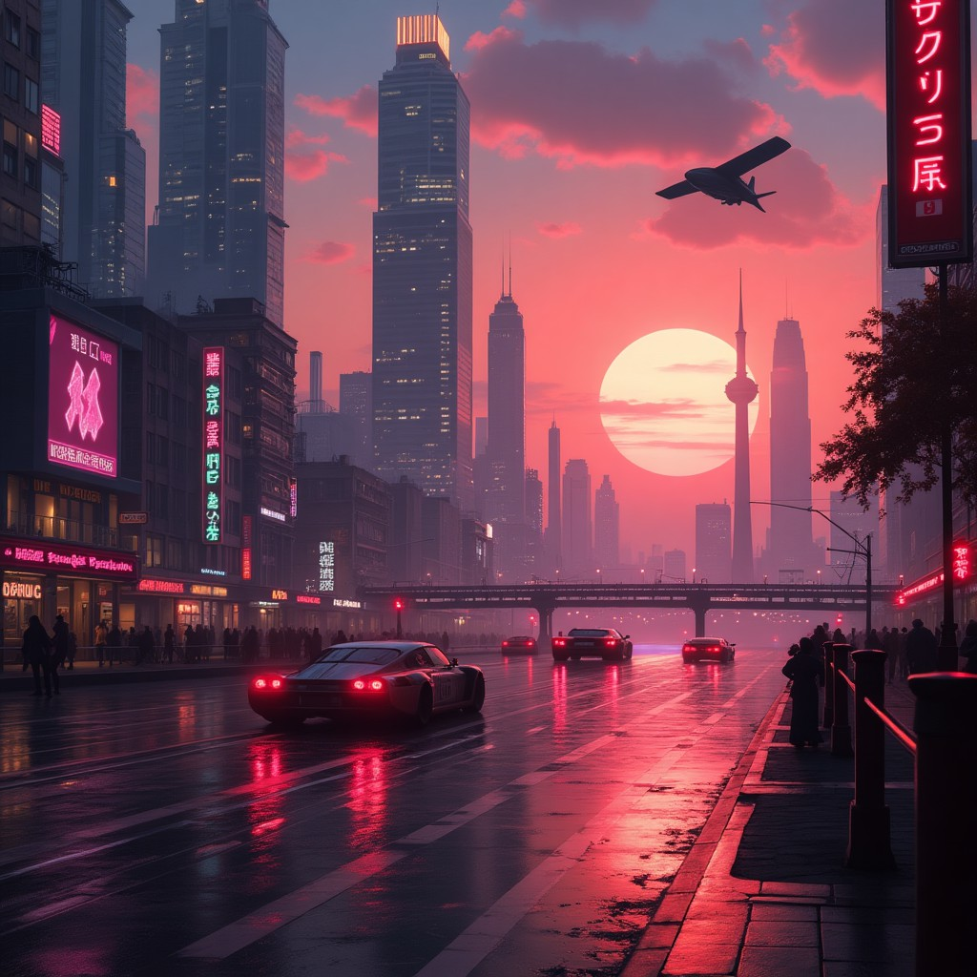

# Image from imagine.art

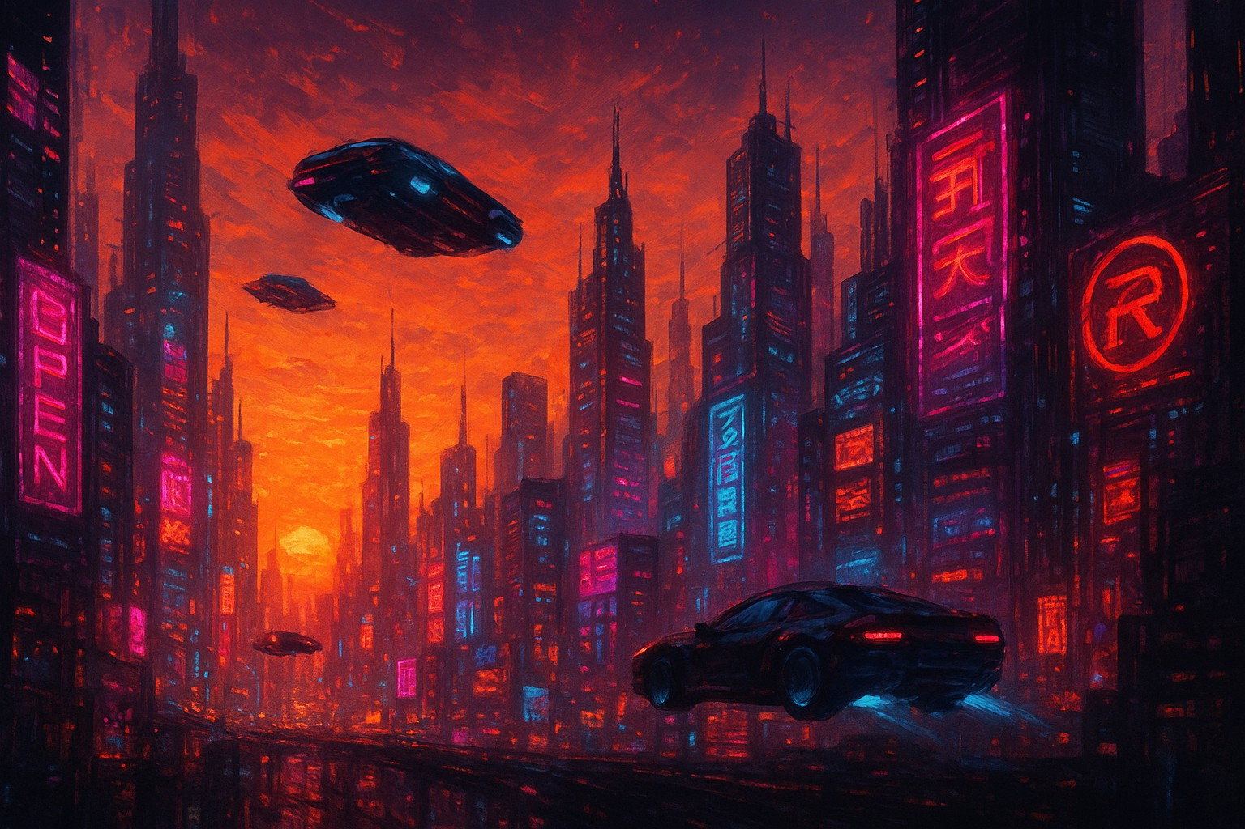

1. ***Image from ChatGPT (Dall.E-3)***

**Task 2: Visual Design Project**

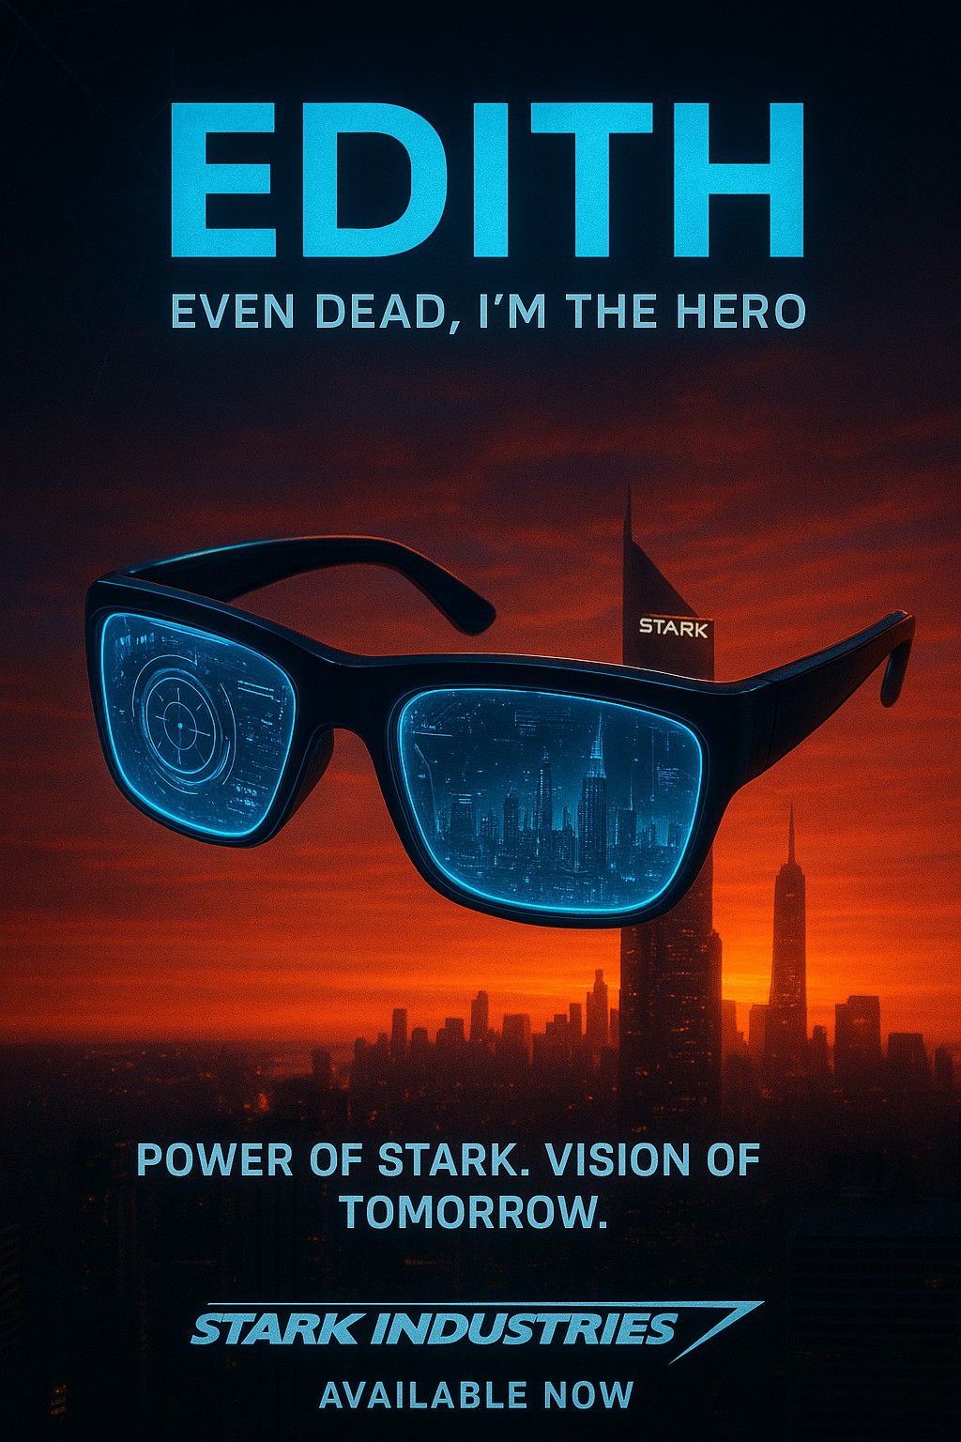

**Prompt:** *“A cinematic Marvel-style product poster inspired by Spider-Man: Far From Home, showcasing the EDITH smart glasses designed by Stark Industries. The glasses glow with holographic blue HUDs, AI data projections, and a futuristic digital interface. Background features a*

*dramatic city skyline at sunset with Stark Tower glowing, subtle Spider-Man*

*themed details like a red-blue color tone and web motifs. High-contrast, cinematic lighting, sleek sci-fi design, ultra-realistic, polished like an official Marvel movie poster. Include space for product text and tagline.”*

***Conclusion***

This assignment provided a practical understanding of how modern AI image generators work and their applications in creative and educational contexts. Through comparative research (Task 1), we observed that different AI tools such as ChatGPT’s DALL·E 3 and Imagine.art offer unique strengths in terms of image quality, prompt accuracy, usability, and style flexibility.

In Task 2, we applied these tools to design a fictional product poster for EDITH glasses (inspired by Spider-Man: Far From Home), demonstrating how AI can assist in marketing, branding, and visual storytelling. In Task 3, we generated concept art for an educational topic, showcasing how AI can be leveraged as an innovative tool for teaching aids and classroom visuals.

Overall, this experiment highlights both the **creative potential and practical limitations** of AI image generators. While they provide fast, customizable, and visually striking results, careful consideration must be given to ethical issues such as copyright, bias, and misuse. With responsible use, AI-generated visuals can significantly enhance fields like advertising, education, content creation, and entertainment.